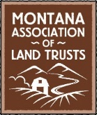
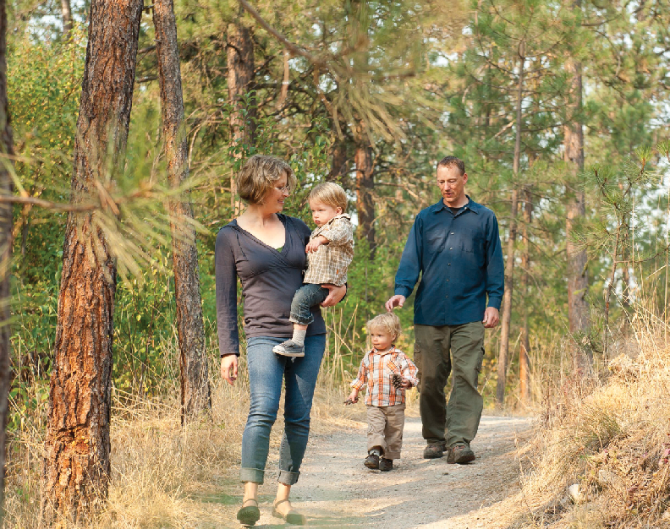
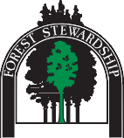
Ties to Land bro 2018 _Layout 1 2/22/18 10:45 AM Page 1

Ties to the Land...

is coming back to Montana!
Ties to the Land, a workshop designed to assist land owners with succession planning, has helped property owners throughout the northwest and will be in Kalispell on Monday, April 30, 2018. Forest landowners, farmers and ranchers are welcome to attend and participate in the workshops.

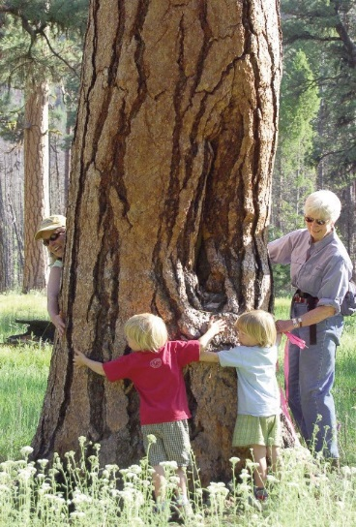
Ties to the Land features a full-day interactive workshop to assist families to understand the basics of—and value of— family succession planning. Costs of the workshop are $50 for the first family member and $10 for each additional family member.

The Ties to the Land presentations, video clips and discussion work best with multiple family members participating in
the workshop.

Because of the personal interactive nature of the workshops, seating is limited
to 25 people per workshop, so please register soon. This is a tremendous opportunity for land owners to learn how to effectively plan your legacy with your family’s goals and values in mind.
Ties to the Land...

Endorsements by Fellow Montanans:
My family attended this workshop because we have the same dilemma so many other families have: What happens to the place when we’re gone?
“
”
- Ed Levert, Chairman of the Montana Forest Stewardship Foundation

This tried and tested workshop curriculum
“
has had excellent reviews from landowners in Idaho, Washinton, Oregon and California. Now, Montana landowners and their family members have the same opportunity to begin charting a course for succession of family property. We all know taking the first step is often the greatest challenge. This workshop offers the guidance necessary for families to plan together for a successful future.
”
– Gary Elllingson, Northwest Management, Inc.
Montana Tree Farm strives to give people the tools they need to be effective stewards of Montana’s forests. Family forests are vital to our state's clean water, air, wildlife habitat, and recreational activities, plus, they produce jobs and wood products that we all use. Workshops such as “Ties to the Land” help us achieve our goals in providing these tools to others.
”
“
- Mark Boardman, Stoltze Land & Lumber and Montana Tree Farm

Family forest land owners are a critical piece of the Montana forestry puzzle. Good succession planning is essential to the sustainable management of privately held forest lands, and all the benefits Montanans derive from them.
“
”
- Bob Harrington, Former Montana State Forester, DNRC

Ties to the Land Workshop

Succesion Planning for Landowners
The Human Side of Estate Planning

April 30, 2018 -

MT Fish, Wildlife and Parks
Kalispell

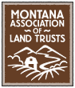
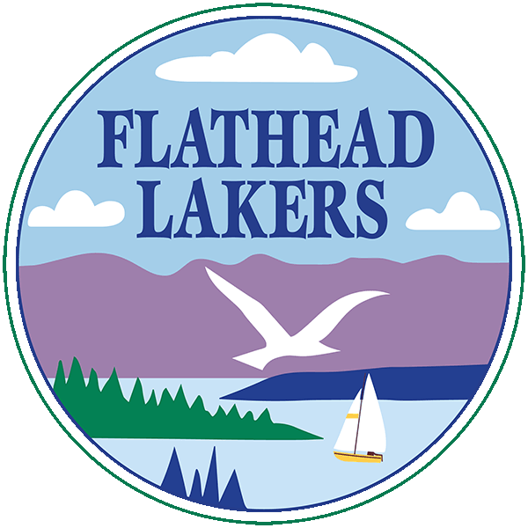
Presented by:

Ties to Land bro 2018 _Layout 1 2/22/18 10:45 AM Page 2
Kalispell - Monday, April 30, 2018
9:00 AM-5:00 PM
MT Fish, Wildlife and Parks, 490 North Meridian Rd.
Conference Room

Your family forest legacy: Planning for an Orderly Transition– Intergenerational Family Forest Project
Millions of acres of family-owned forest land in the U.S.—and thousands of Montana family-owned forest lands—will change hands in the next few years. Some forests and other rural

lands may be converted to a different use because owners didn’t take charge of the succession process in time. There are many reasons for this:
- Landowners may have a strong desire to pass their land on to their children but have not yet done the work necessary to ensure that result.
- Many landowners haven’t talked to their children about who will take care of the family farm or forest after they’re gone.
- Some owners have realized their children may lack the skills to manage the family land or may not be interested in doing so.
- Others assume that succession planning will be too expensive, and they aren’t sure what the benefits will be. Other owners wait for their children to take the initiative. Or maybe they just don’t know what to do next.
If any of these describe your situation, this Ties to the Land workshop is for you!
Workshops are sponsored by the Montana Forest Stewardship Foundation and the Montana Association of Land Trusts
Workshop Program Content
Ties to the Land includes presentations, video clips, and interactive exercises on the following topics:
Please return this form with a check ($50.00/first family member + $10/each additional family member attending) no later than April 20. A Ties to the Land workbook will be provided to each family. If you would like additional workbooks, please add $25 per workbook.
I/we plan to attend Ties to the Land:
Number of people attending: _______ Amount Enclosed: $ ______________

10 Steps to Successful Succession Planning
- Passion, Preparation, and Planning
- Family Ties, Differing Objectives
- Generation Gaps
- The Heirloom Scale, Values and Goals
- Conflicting Roles of Family and Business

Tips for a Successful First Family Meeting
Ties to the Land Registration Form
To register return this form with registration fee by April 20 to: Montana Forest Stewardship Foundation, PO Box 1056, Libby, MT 59923. Make checks payable to: Montana Forest Stewardship Foundation.

Guidelines for Good Communication
NAME(S):____________________________________________________________________________________________________________________
ADDRESS: ___________________________________________________________________________________________________________________
CITY / STATE / ZIP:_____________________________________________________________________________________________________________
PHONE:_______________________________________________________ EMAIL:__________________________________________-______________

Choosing the Best Team of Advisors for You
NUMBER IN FAMILY ATTENDING: ________ Registration fee (per family or ownership) includes one workbook, CD, and refreshments.
Questions? Please call or email Ed Levert, 406-293-2847, televert@kvis.net
- Putting the Plan Together, Success Strategies
- Transferring Ownership
- Legal and Financial Instruments
Open to agricultural producers, forest landowners, and…. (other?)
Your Ties to the Land Workshop Instructors

Montana welcomes Madeline and Kirk David to to facilitate Montana’s Ties to the Land workshop. Madeline and Kirk have a wealth of experience with family succesion planning, and forest management. Thanks to Madeline and Kirk for bringing Ties to the Land to Kalispell on April 30, 2018.

Both Kirk & Madeline David:
Family forest landowners (Idaho, Montana, & Florida), Tree Farmers, Idaho State Tree Farm Committee members, Aldo Leopold Foundation Land Ethic Leaders, “Ties to the Land” Facilitators in WA, ID, MT from 2008 to the present.
Separate along perforation

Kirk: Society of American Foresters Fellow, ATFS Tree Farm Inspector Trainer, Idaho Forest Owners Association Executive Vice President
Madeline: LLC Business Owner/Manager.

